Arik Brooks 2/2/21

Daily Corrective Exercise Routine
Monday | Wednesday | Friday

Set 1: Do 3 rounds Do both of exercises in Set 1, then move to next set
Prone Ankle Squeeze: Lie on your stomach, palms down and chin resting on the hands. Place a pillow between the ankles. Bend the knees while still holding the pillow to a 90 degree angle. Squeeze and release the pillow using only the ankles. You should feel a contraction in the buttocks. If not, widen the knees slightly. Remember to focus on the ankles and not the buttocks as you squeeze the pillow.
(x15)
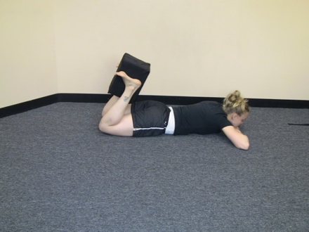
http://www.youtube.com/watch?v=2s4HE4r1ZmM

BAND ON KNEES, LIFT KNEE AND FOOT
Clams– side lying: Lie on your side, with your head resting on your hand. The knees are together and bent to about a 90-degree angle and the thighs should be on a 45 angle from the upper body. This should line your anklebone up with your hip joint. Hold your abdominals in to keep your pelvis still. Keeping the ankles to together, lift the top knee toward the ceiling and then return to the start and repeat. Lift only as high as you can keeping the ankles together. (x15)
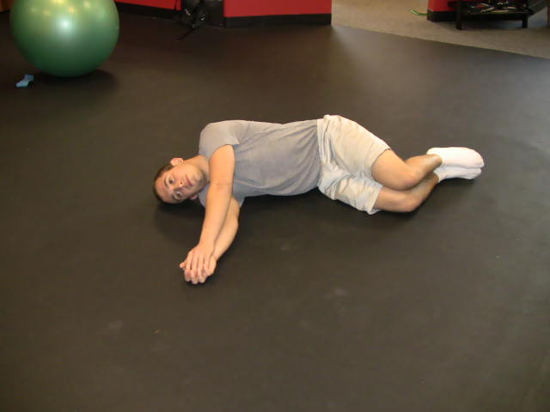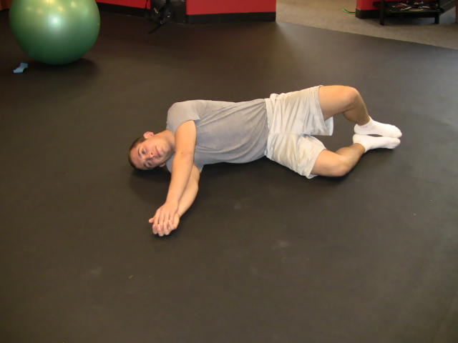

Set 2: Do 3 rounds

USE BAND AROUND KNEES INSTEAD OF STRAP
Knee Presses - Supine: Lie on your back with knees bent and feet flat on the floor. Feet should be a little bit wider than hip width apart. Tie a belt or strap around the thighs. Press the knees out to the sides and relax, trying to spread the knees apart. (x15)
http://www.youtube.com/watch?v=6yShLvk7yoA

USE BAND AROUND KNEES
Active Shoulder Bridges: Lie on your back on the floor. Knees bent and feet flat on the floor. Keep ankles and knees in alignment with the hips. Arms out to the sides, shoulder height. Lift the buttocks off the floor. Do not allow the knees to fall apart, keep the knees in alignment with the hips. Lift up as high as possible, squeezing the buttocks together. Relax the upper body (shoulders still on the floor). Lower the buttocks to the floor and repeat. (X15)
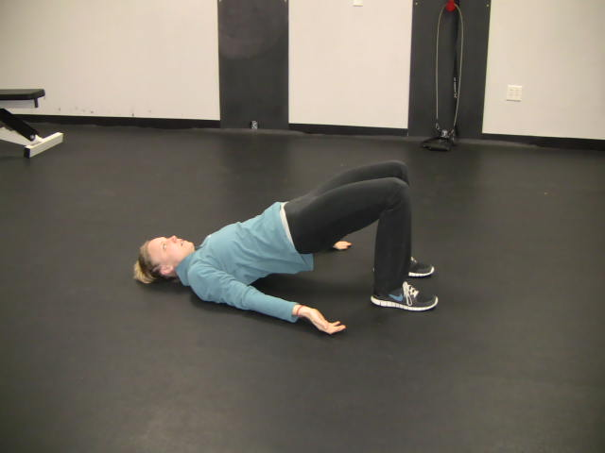
http://www.youtube.com/watch?v=MP879DGYGF4&list=PLl25pSFox7CBj0McfjXmlDYso9H3t8gx1&index=2

Set 3: Do 3 rounds
Quad Lifts – Sitting Floor: Sit on the floor with your back against a wall. Roll the hips forward creating an arch in the back, legs straight out in front of you. Tighten the quadriceps (thighs) and flex the feet so that the toes are pointing back towards you. Flatten the upper back and head against the wall. Squeeze the shoulder-blades together without shrugging the shoulders. Relax the arms and hands, palms up, on your lap. From here, lift the leg off the floor approximately 3-5 inches and lower. Check the arch in the back. Switch legs and repeat. Keep alternating legs for the desired number of repetitions. (x 10) If I cant do this, put arms behind and lift
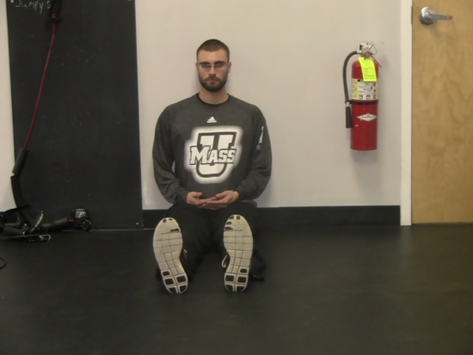

Double Double, Supine, Switch, with Lift: Lie on your back with the knees bent, in alignment with the hips and hip width apart. Tie a belt or strap around the ankles and place a pillow between the knees. Relax the head and shoulders, palms up. Pull the ankles apart against the strap and at the same time as you squeeze the knees into the pillow. Holding these positions, lift and lower the feet approximately 4-6 inches off the floor. Remember to apply constant pressure into the pillow with the knees and constant presses pressing outward against the strap with the ankles. Relax and repeat the process. Continue for the desired number of repetitions. (x 20)
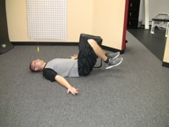
https://www.youtube.com/watch?v=K7eEUdkI2kA

Double Double- Supine with Lift: Lie on you back, knees bent and in alignment with the hips. Tie a belt or strap around the knees (knees should be hip width apart) and place a pillow between the ankles. Relax the head and shoulders, palms up. Squeeze the pillow with the ankles and hold. AT THE SAME TIME pull the knees apart against the strap. Holding these positions, lift and lower the feet approximately 4-6 inches off the floor. Remember to apply constant pressure into the pillow with the ankles and constant pressure on the knees pressing outward against the strap. (x 20)
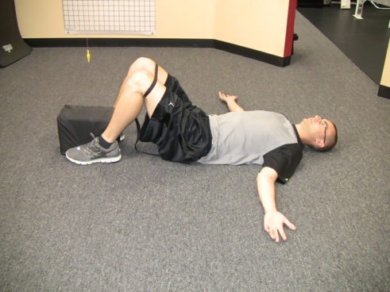
https://www.youtube.com/watch?v=uZR3OoRZ1W4

USE BAND AROUND KNEES
Squat Doorway: Holding onto a railing or doorknob for support at waist level, bend the knees, sitting back towards the floor, arching the low back and flattening the upper back. Lower the body so that the knees and hips are parallel and you are sitting at a 90 degree angle. The arms should be straight with the weight in the heels and evenly distributed to both hips. (:30 - 2X)
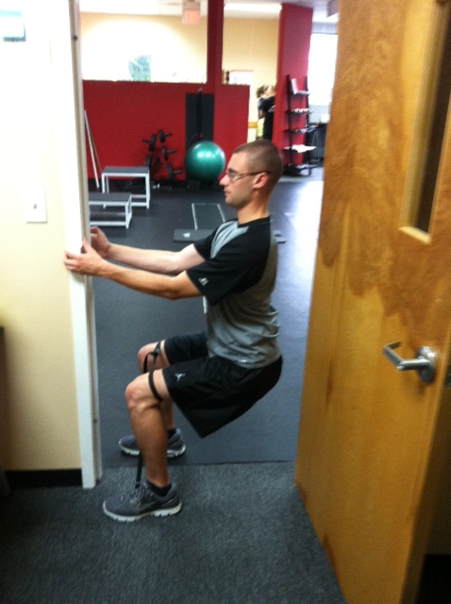
https://www.youtube.com/watch?v=YcfsAYf1k04

